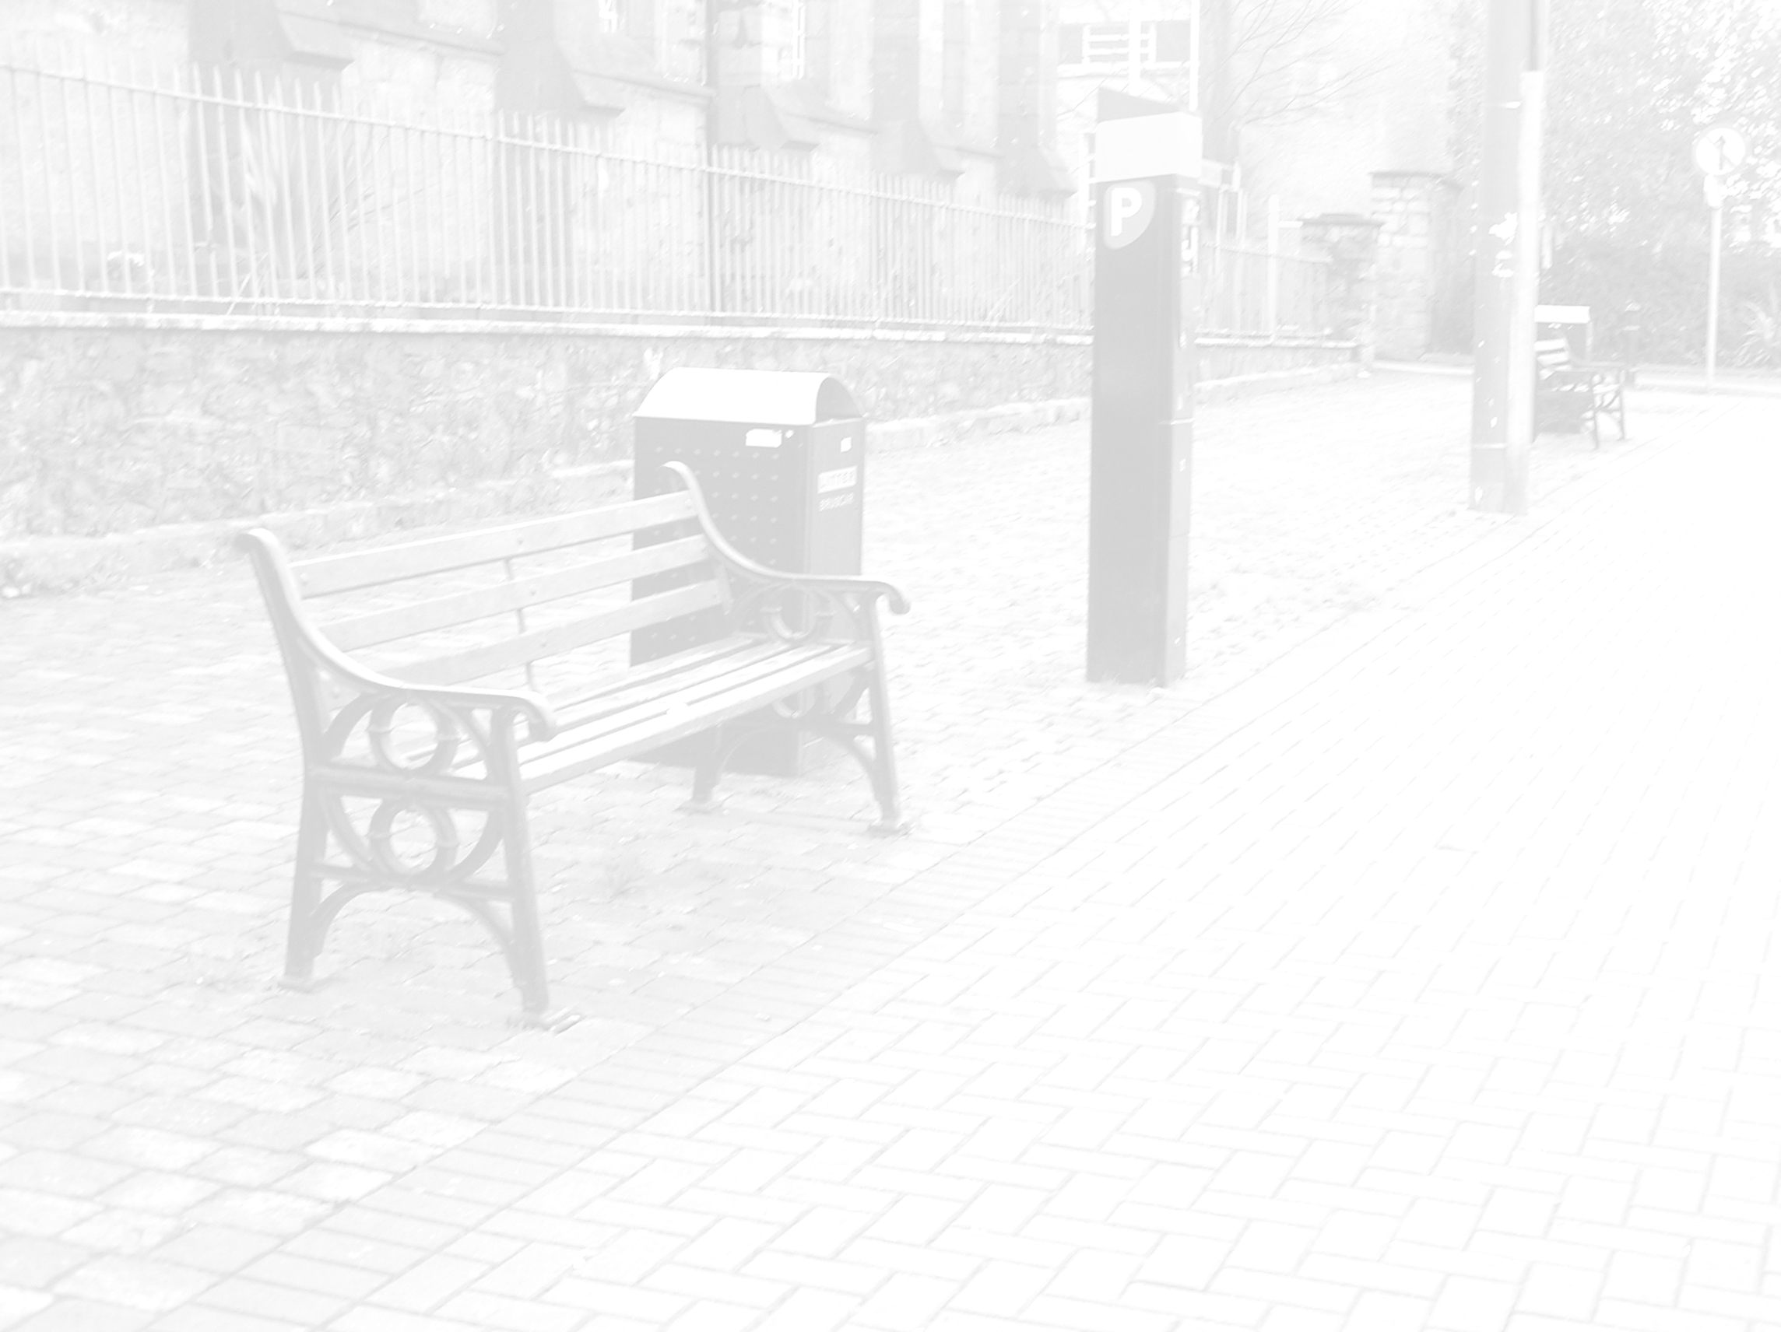
  - Careful positioning of street furniture provides easier access and reduces potential hazards, particularly for people with visual impairments.
  - Clearly defined routes should be planned for pedestrians. Consider use of both colour contrast and textural changes in paving, logical grouping of street furniture, including landmarks for orientation as well as visual clues that incorporate audible and olfactory clues such as fountains and fragrant flowers and effective lighting to define routes.
  - Avoid where possible placing street furniture where it causes problems for people with visual impairments or obstructs the passage of wheelchair users. Seating should be located in sheltered places where people can enjoy a good and clear view, and after a long sequence of paths and changes on level. Seats should be placed 600mm back from the line of movement so that they do not block the path. The surface should be flush with surrounding levels, as well as firm and stable. A 800 x 1300mm square of firm paving beside a seat will allow a person using a wheelchair to sit with other people. A seat should be no less than 450mm high, although a perch 500-750mm will be easier to use for some people who have difficulty getting up. A heel space at least 100mm deep will also make it easier for people to get off the seat or perch. Seats with backrests are useful for additional support, and arm rests are also useful to lean against, as well as assisting in getting up out of the seat.
  - If items of street furniture have to be located within access routes, they should be clearly identified, for example using colour contrasting and luminance with the background against which they will be seen.
  - The provision of appropriate seating is important, especially on long or sloping routes. Seating should be provided at regular intervals and should be located not more than 50m apart where possible.
  - Avoid low headroom and safeguard building projections such as signage and hanging baskets. Areas below stairs or ramps where there less than 2100mm headroom above ground level should be protected by guarding and low level cane detection, or a permanent barrier giving the same degree of protection.
  - Bollards should be a minimum of 1000mm in height, 250mm in width and tonally contrasted with background. Adjacent bollards should not be linked with a chain or rope. Bollards should be a minimum of 1200mm apart.
  - Freestanding posts or columns which obstruct the safe movement of pedestrians should be incorporate a band of contrasting colour or luminance at 1500-1650mm.
An additional band at 850-1000mm might also be considered. Two medium bands of colour a little distance apart would be more visible than one broad band of colour.
  - Cycle parking areas should be clear of pedestrian routes, and cycle stands should be clearly visible even when not in use.
  - Hedges and planting, to be maintained regularly to prevent overgrowth onto pedestrian accesses.
  - Refuse Bins to be placed out of the way of pedestrian routes on bin collection days.
  - Sandwich Boards to be prohibited from all pedestrian routes.
Ref. Designing for Accessibility 2004 p.50.
AU 1428 (2001)

